Composite Solids with Flat and Hemispherical Surfaces

Definition
# Source: AI Source: Provided by: [Data Path: Persons Table -> ID Column: 1, Name_En Column: Motasem Essam] -> From: [ChatGPT] on [7/25/2026]
Composite Solids with Flat and Hemispherical Surfaces are three-dimensional geometric solids formed by combining two or more solid components whose external boundaries include flat planar surfaces and hemispherical curved surfaces.
These composite solids contain planar faces, such as squares, rectangles, triangles, and circles, together with one or more hemispherical curved surfaces. They are commonly formed by combining hemispheres with prisms, cubes, cylinders, pyramids, and other solid shapes.
Unlike complete spherical surfaces, hemispherical surfaces represent exactly one-half of a spherical surface. A hemisphere has one flat circular base and one curved hemispherical surface.

Simple Definition
# Source: AI Source: Provided by: [Data Path: Persons Table -> ID Column: 1, Name_En Column: Motasem Essam] -> From: [ChatGPT] on [7/25/2026]
A composite solid with flat and hemispherical surfaces is a 3D shape that combines flat faces with one or more hemispherical curved surfaces.

Geometric Representation
# Source: AI Source: Provided by: [Data Path: Persons Table -> ID Column: 1, Name_En Column: Motasem Essam] -> From: [ChatGPT] on [7/25/2026]
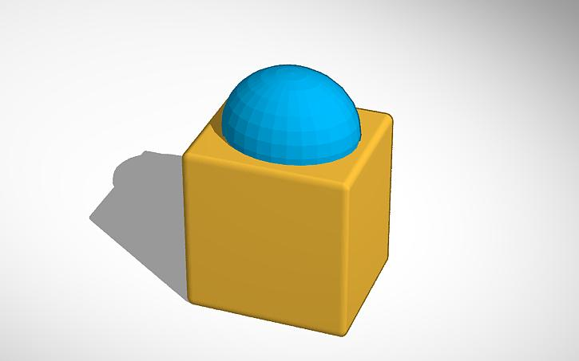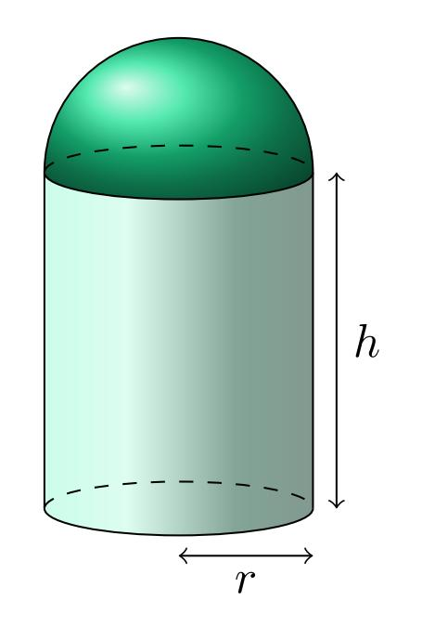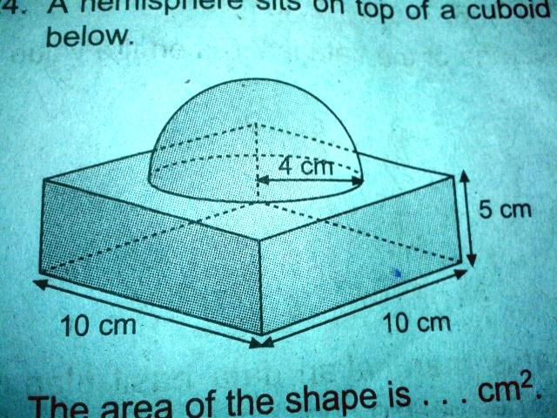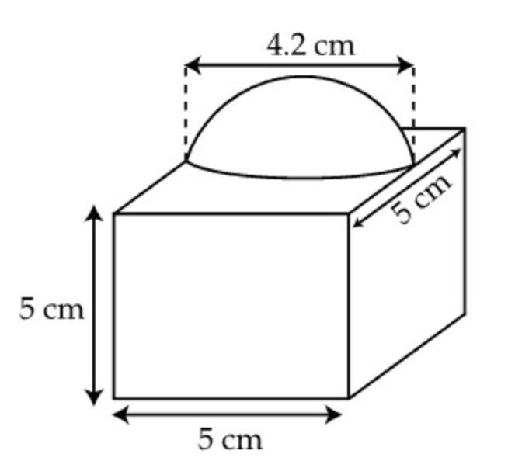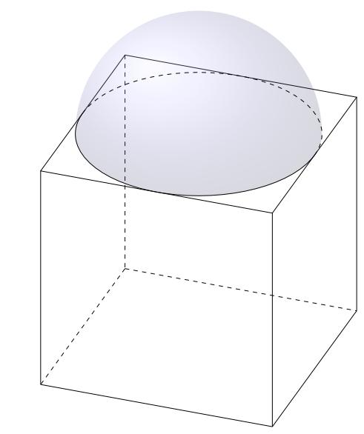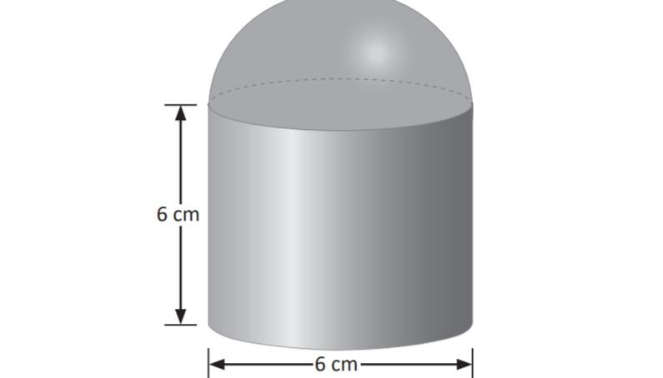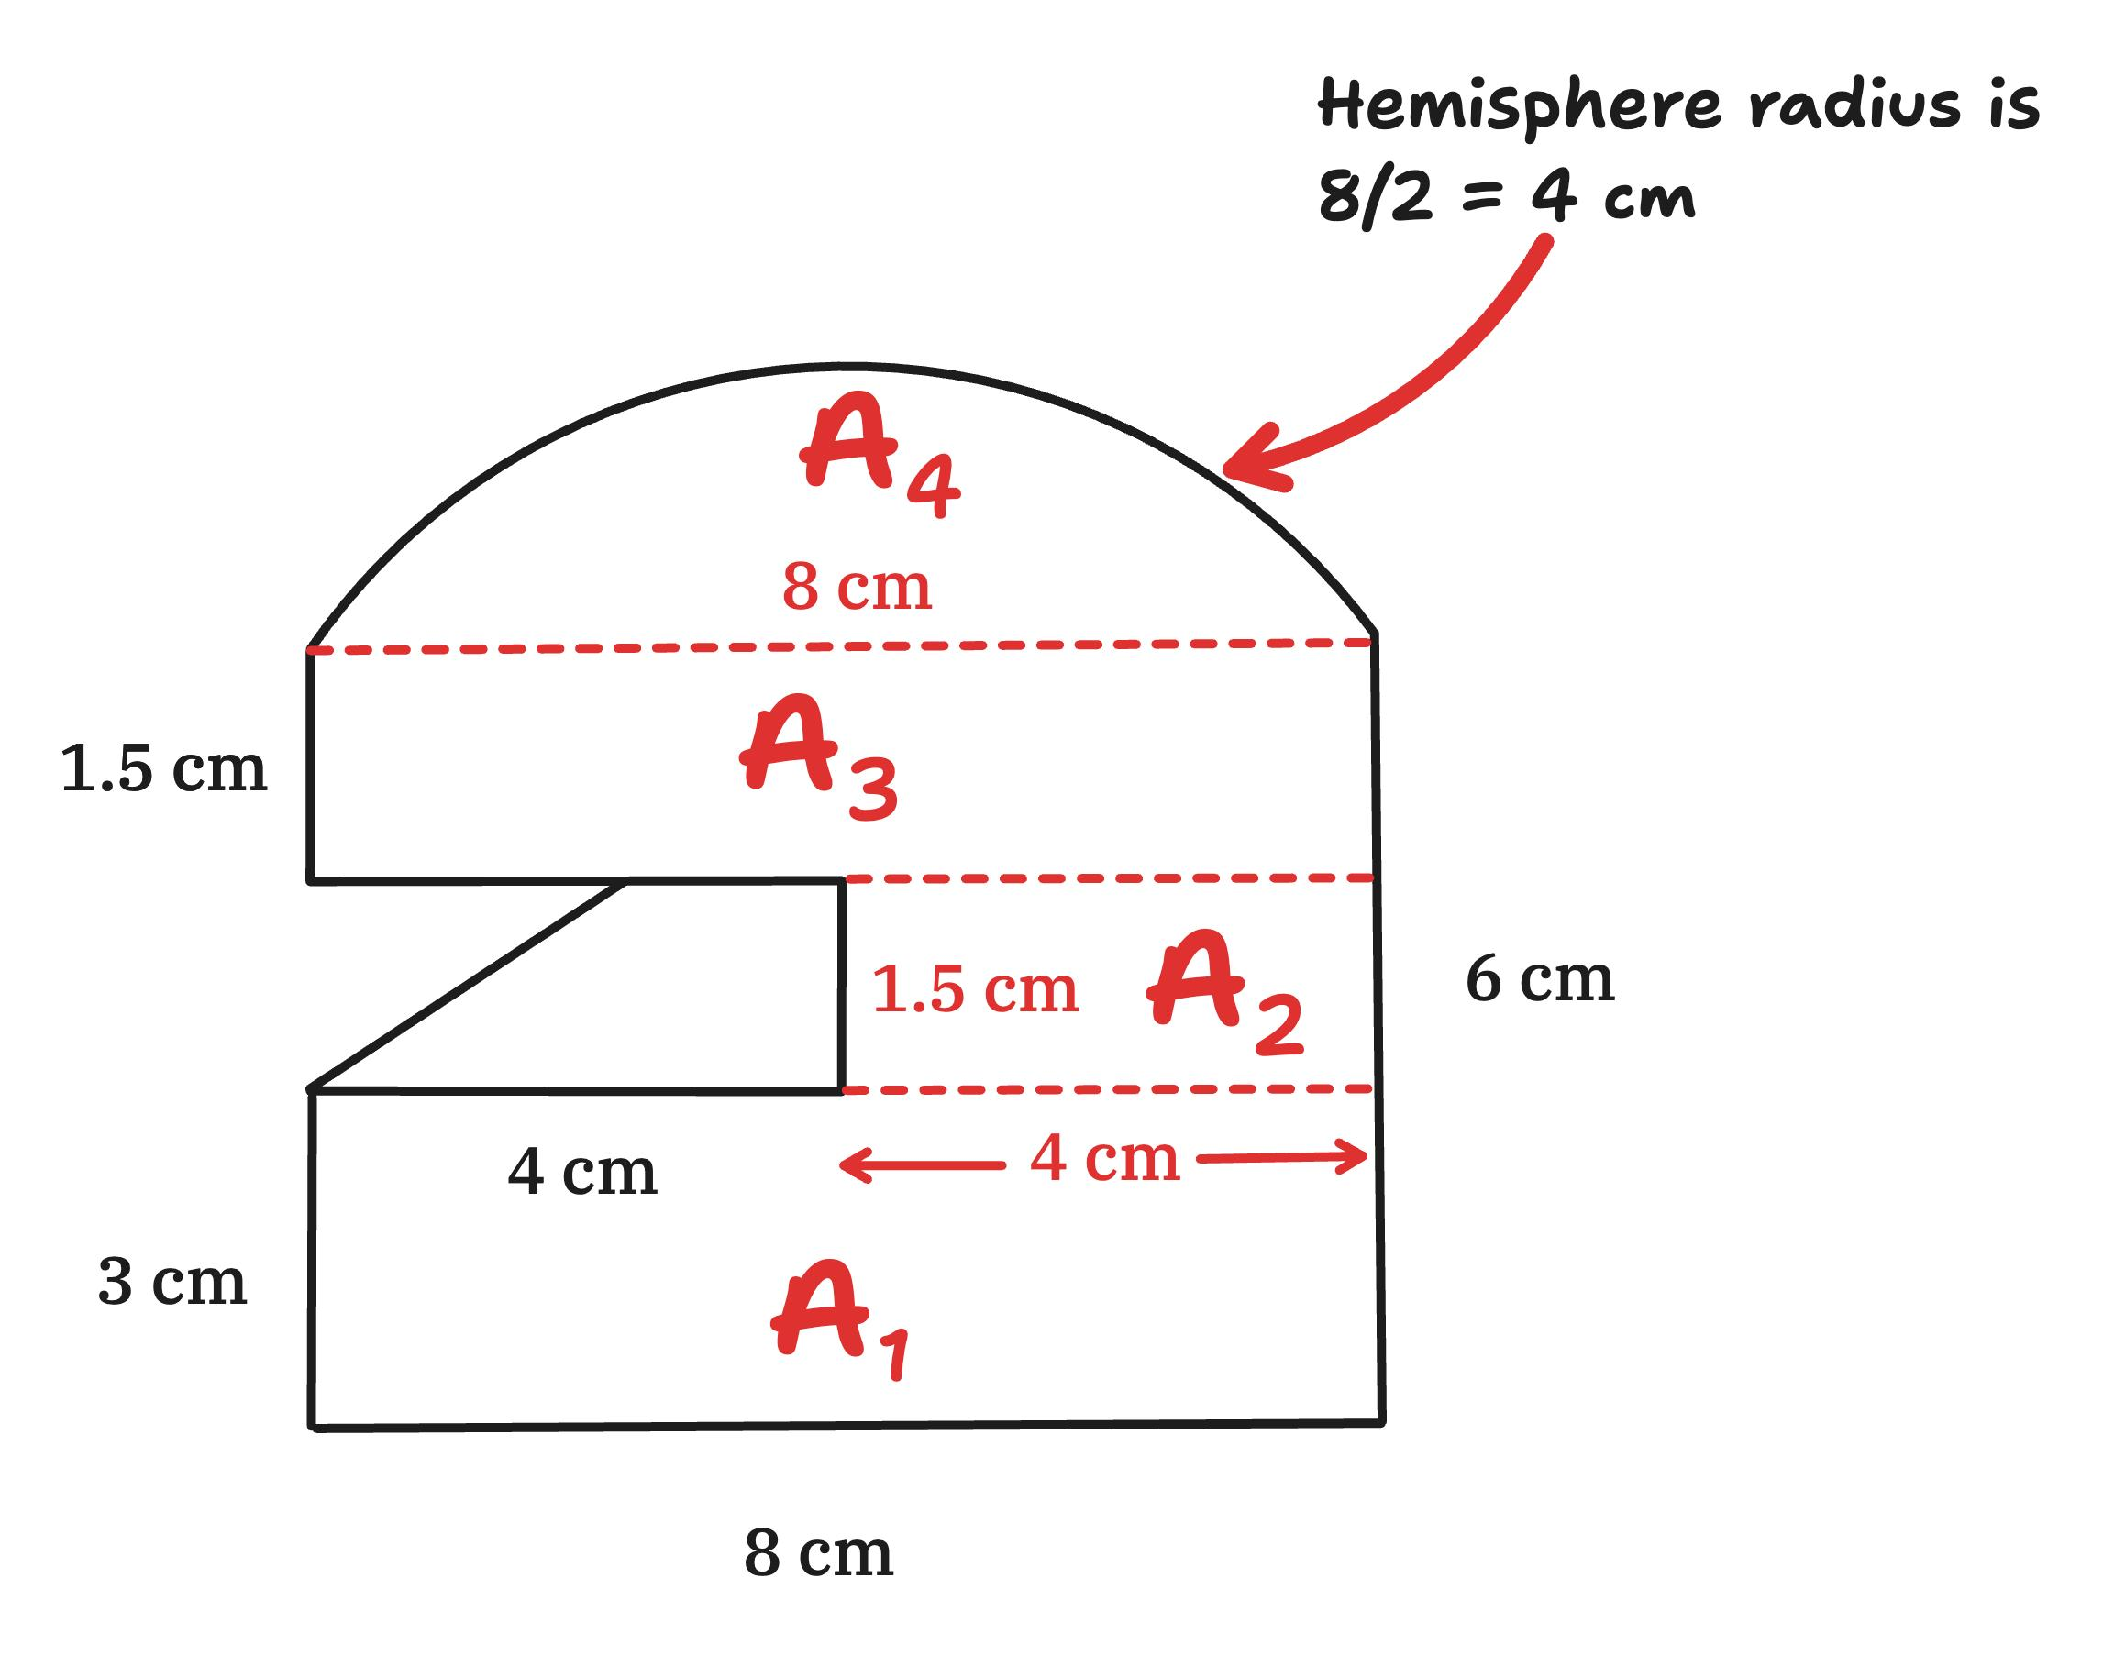
The main surface types are:
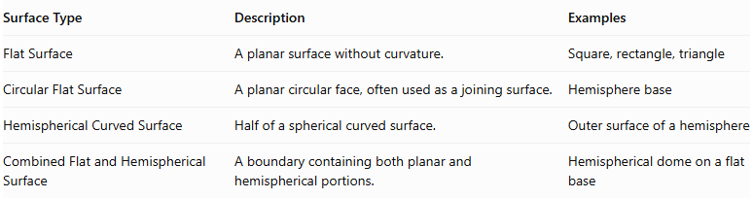
Surface Type | Description | Examples
Flat Surface | A planar surface without curvature. | Square, rectangle, triangle
Circular Flat Surface | A planar circular face, often used as a joining surface. | Hemisphere base
Hemispherical Curved Surface | Half of a spherical curved surface. | Outer surface of a hemisphere
Combined Flat and Hemispherical Surface | A boundary containing both planar and hemispherical portions. | Hemispherical dome on a flat base
Important: A hemisphere consists of one flat circular base and one curved hemispherical surface. When attached to another solid through its circular base, that base becomes hidden, leaving only the curved hemispherical surface exposed at the joining location.

Main Classification
# Source: AI Source: Provided by: [Data Path: Persons Table -> ID Column: 1, Name_En Column: Motasem Essam] -> From: [ChatGPT] on [7/25/2026]
Composite solids with flat and hemispherical surfaces can be classified according to the types of flat-faced components combined with hemispheres.

Prism-Based Composite Solids
# Source: AI Source: Provided by: [Data Path: Persons Table -> ID Column: 1, Name_En Column: Motasem Essam] -> From: [ChatGPT] on [7/25/2026]
A prism-based composite solid combines one or more prisms with hemispherical components.
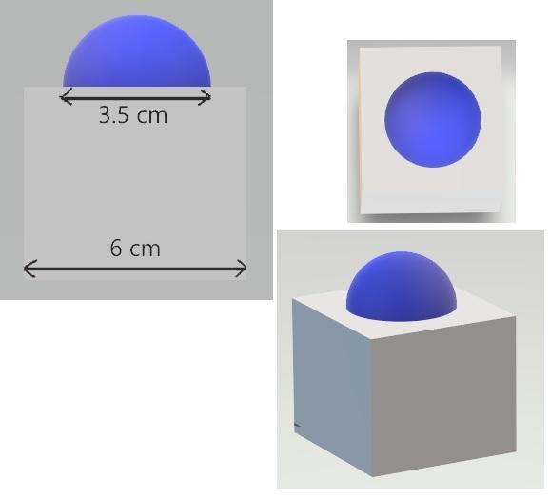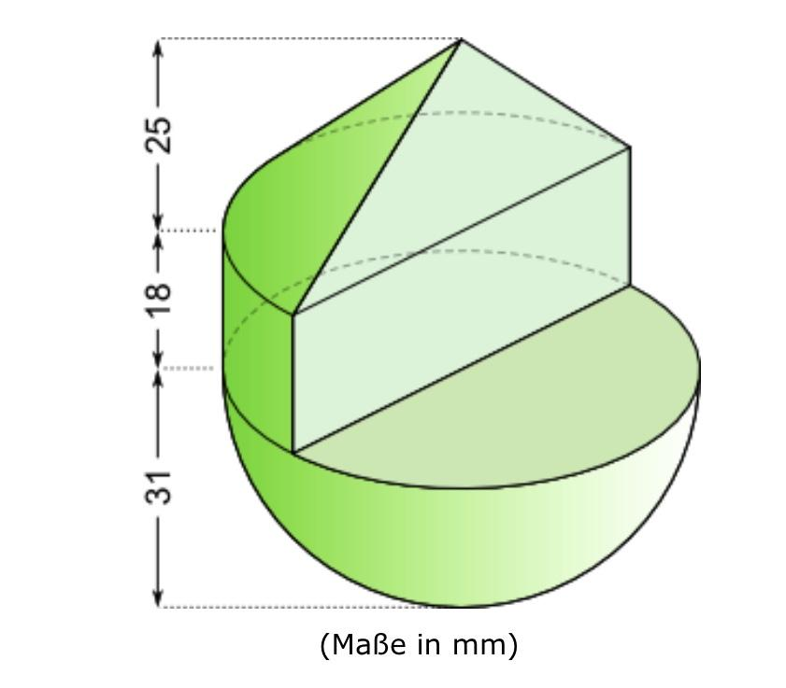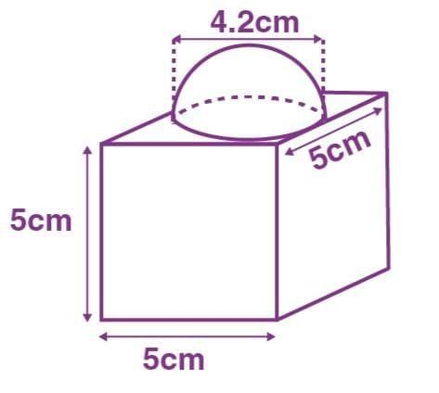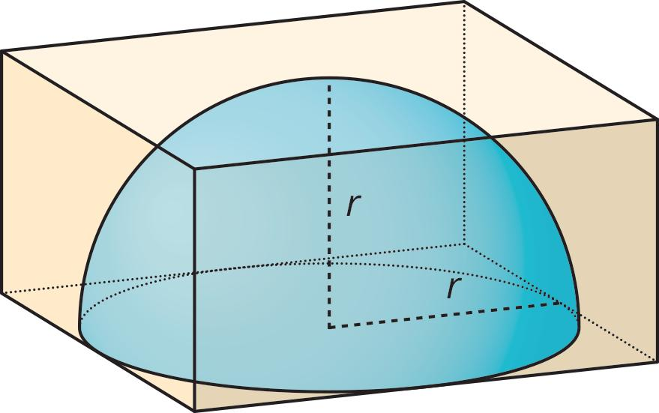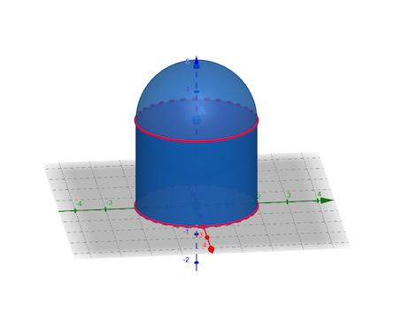
Examples:
- Rectangular Prism with a Hemisphere
- Cube with a Hemisphere
- Triangular Prism with a Hemisphere
- Polygonal Prism with a Hemisphere
- Multiple Prisms with Hemispherical Components

Cylinder-Based Composite Solids
# Source: AI Source: Provided by: [Data Path: Persons Table -> ID Column: 1, Name_En Column: Motasem Essam] -> From: [ChatGPT] on [7/25/2026]
A cylinder-based composite solid combines cylinders with hemispheres or multiple hemispherical components.
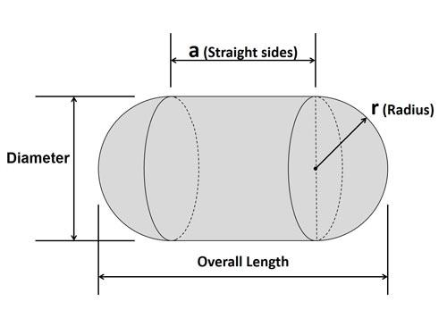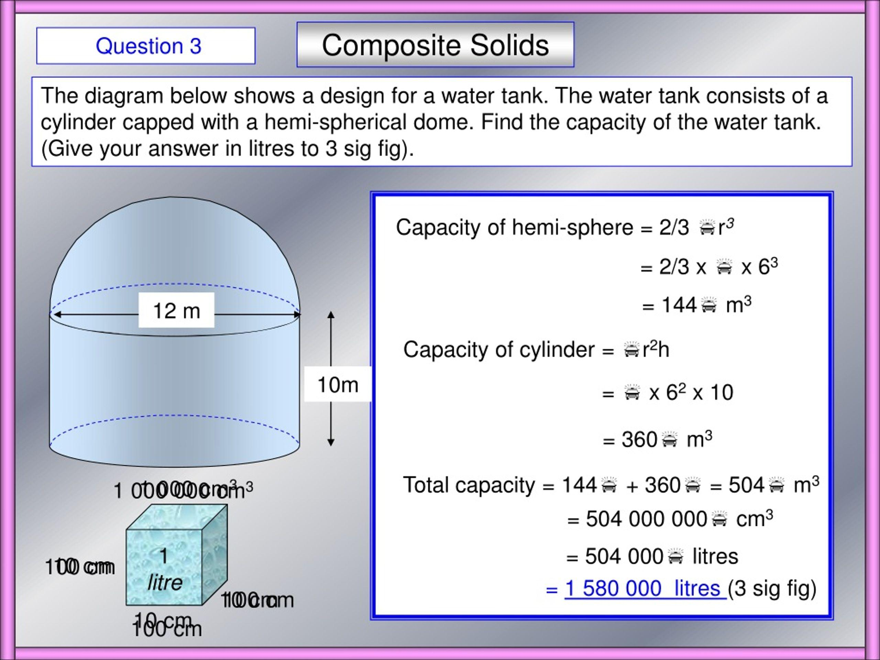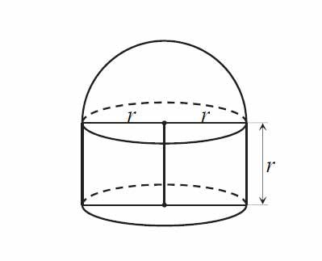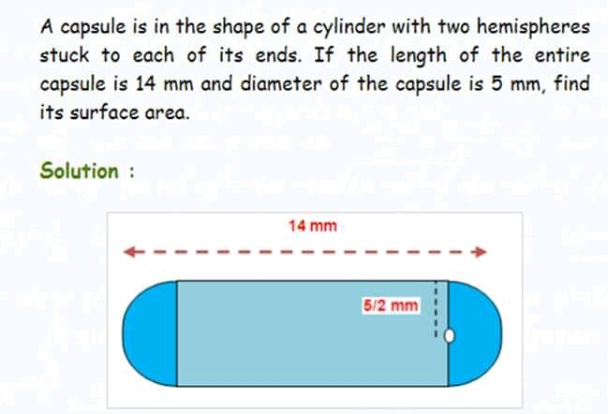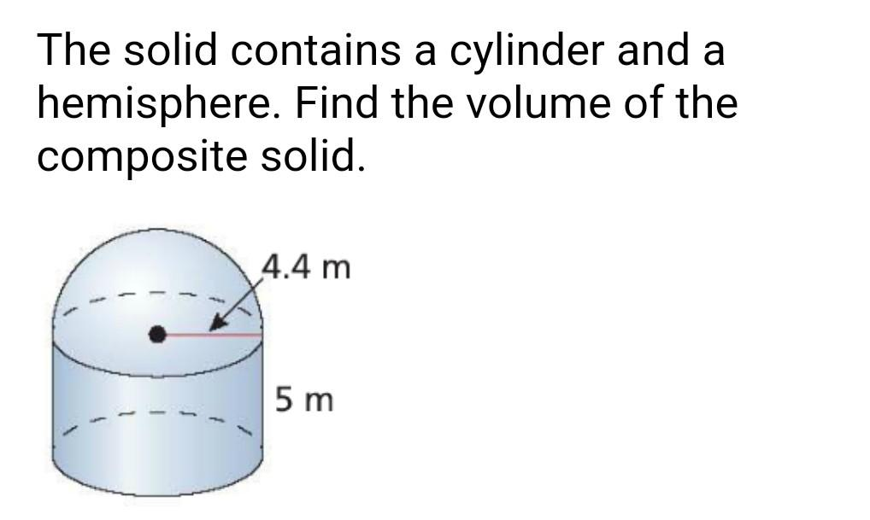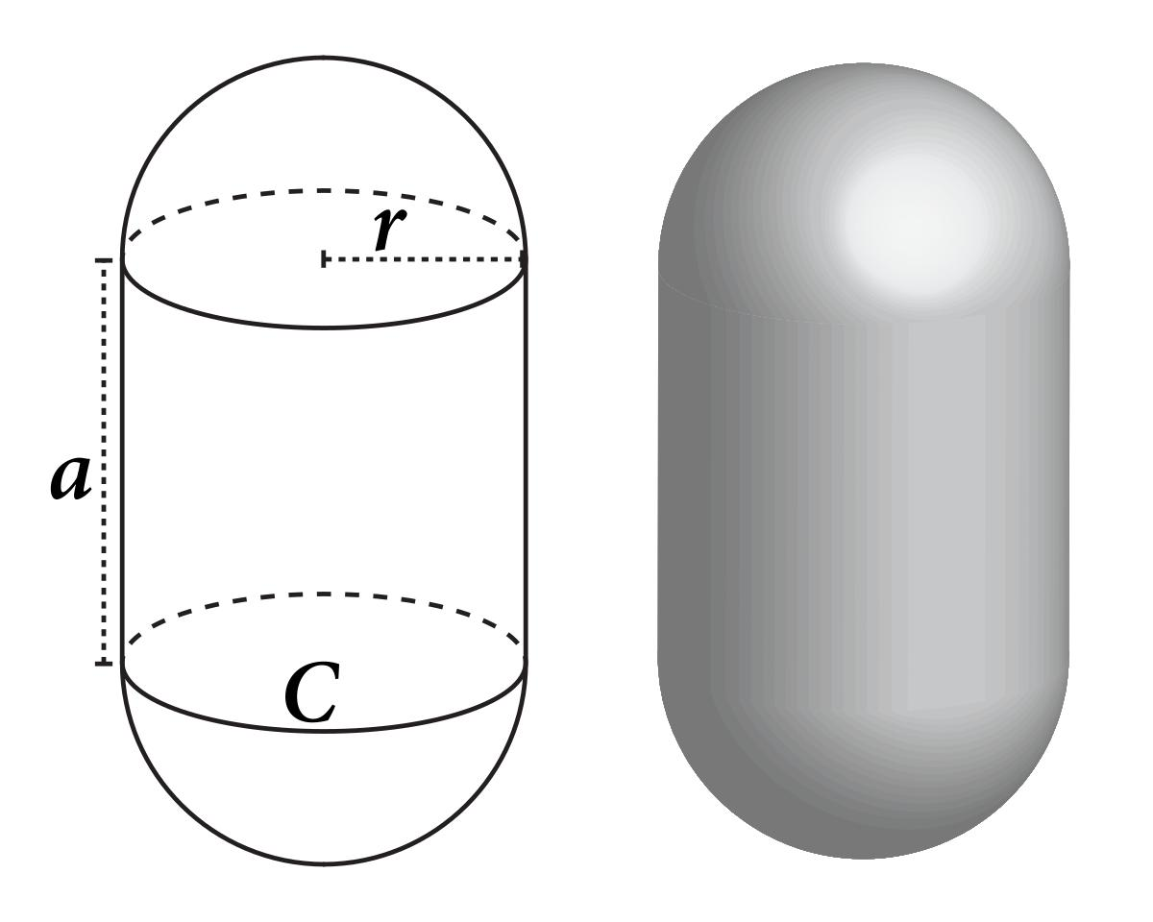
Examples:
- Cylinder with a Hemisphere on Top
- Cylinder with a Hemisphere at the Bottom
- Cylinder with Two Hemispherical Ends
- Cylinder with Multiple Hemispherical Components
- Coaxial Cylinder and Hemisphere

Pyramid-Based Composite Solids
# Source: AI Source: Provided by: [Data Path: Persons Table -> ID Column: 1, Name_En Column: Motasem Essam] -> From: [ChatGPT] on [7/25/2026]
A pyramid-based composite solid combines pyramids with hemispherical components.
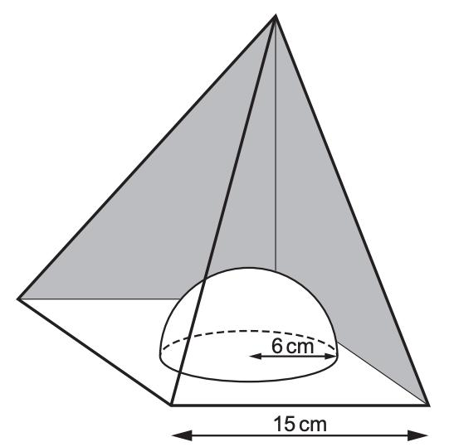
Examples:
- Square Pyramid with a Hemisphere
- Triangular Pyramid with a Hemisphere
- Pentagonal Pyramid with a Hemisphere
- Multiple Pyramids with Hemispherical Components

Hemisphere-Based Composite Solids
# Source: AI Source: Provided by: [Data Path: Persons Table -> ID Column: 1, Name_En Column: Motasem Essam] -> From: [ChatGPT] on [7/25/2026]
A hemisphere-based composite solid combines two or more hemispheres, potentially with different radii, orientations, and arrangements.
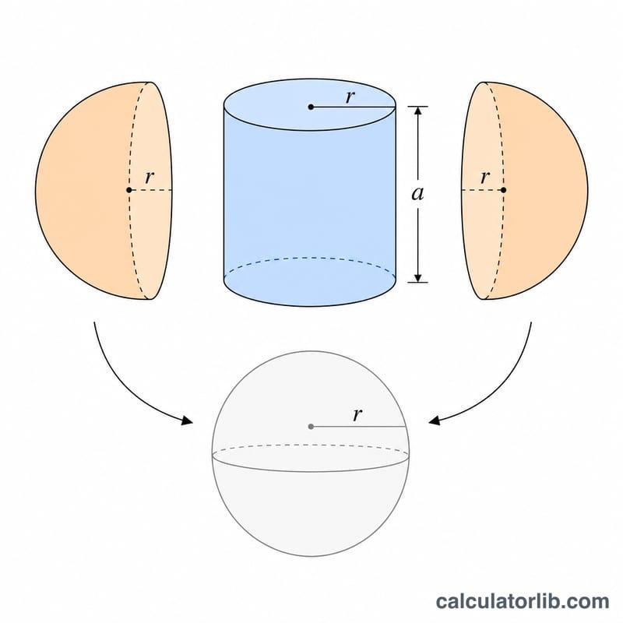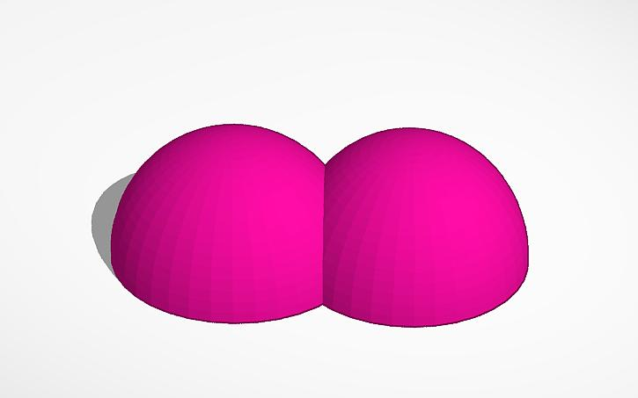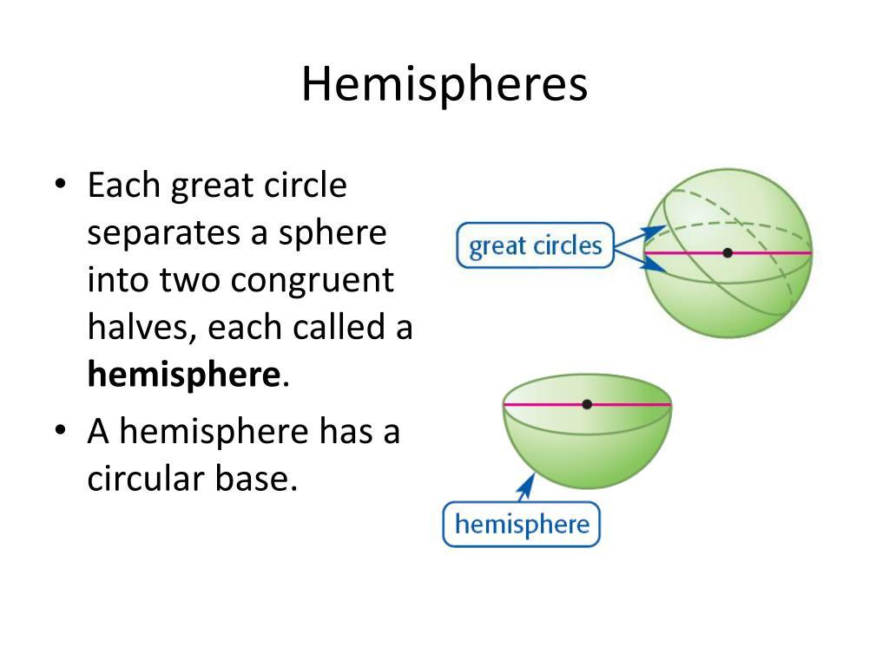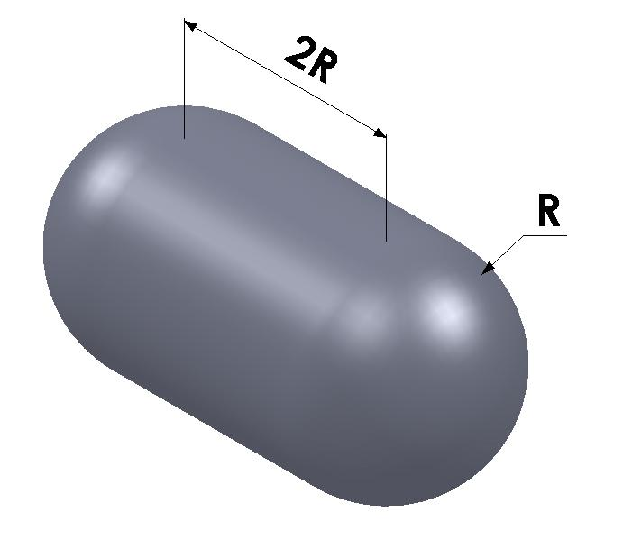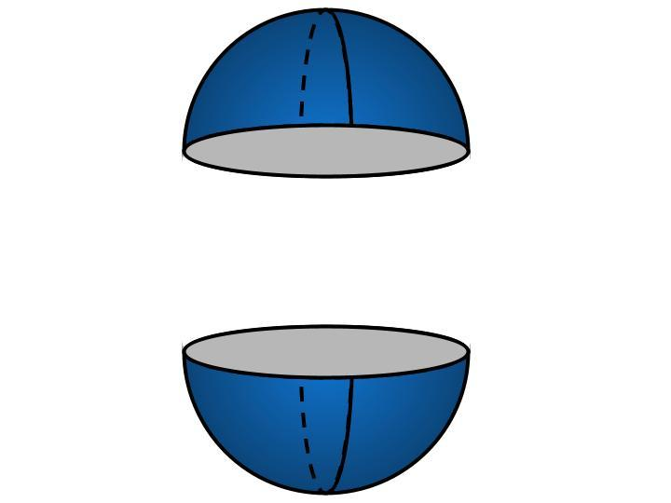
Examples:
- Two Hemispheres Joined at Their Flat Bases
- Two Hemispheres Joined Side-by-Side
- Hemispheres with Different Radii
- Nested Hemispheres
- Multiple Hemispheres with Different Orientations

Mixed-Shape Composite Solids
# Source: AI Source: Provided by: [Data Path: Persons Table -> ID Column: 1, Name_En Column: Motasem Essam] -> From: [ChatGPT] on [7/25/2026]
A mixed-shape composite solid combines hemispherical components with different types of flat-faced solids.
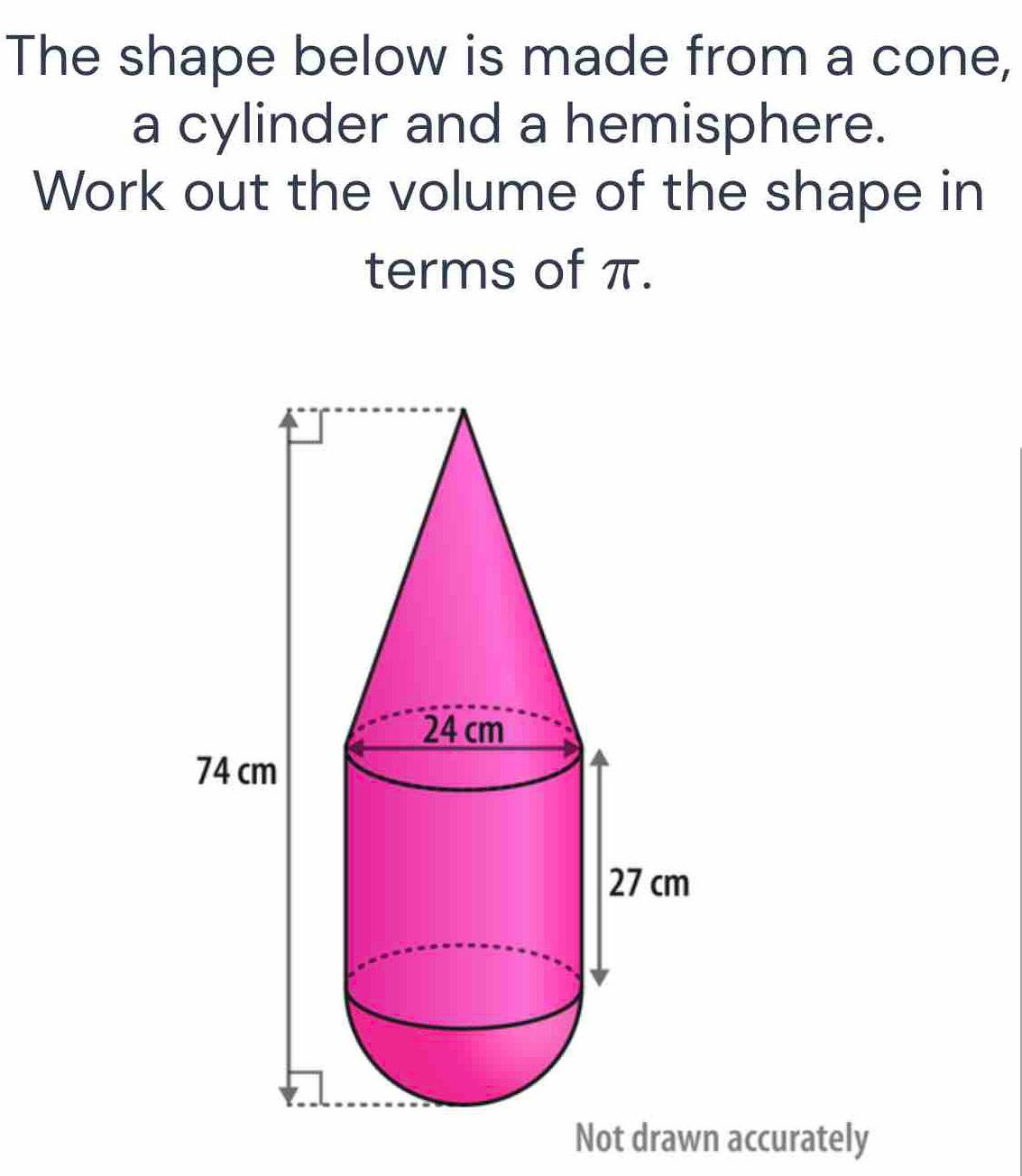
Examples:
- Hemisphere with a Cube and a Cylinder
- Hemisphere with a Rectangular Prism and a Pyramid
- Multiple Hemispheres with Different Prisms
- Hemispherical Components with Cylinders and Pyramids
- Complex Mixed-Shape Composite Solids

Classification by Surface Arrangement
# Source: AI Source: Provided by: [Data Path: Persons Table -> ID Column: 1, Name_En Column: Motasem Essam] -> From: [ChatGPT] on [7/25/2026]
The external surfaces can also be classified according to how flat and hemispherical surfaces are arranged.
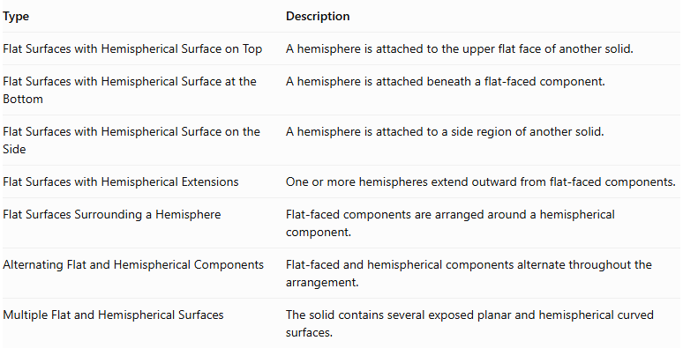
Type | Description
Flat Surfaces with Hemispherical Surface on Top | A hemisphere is attached to the upper flat face of another solid.
Flat Surfaces with Hemispherical Surface at the Bottom | A hemisphere is attached beneath a flat-faced component.
Flat Surfaces with Hemispherical Surface on the Side | A hemisphere is attached to a side region of another solid.
Flat Surfaces with Hemispherical Extensions | One or more hemispheres extend outward from flat-faced components.
Flat Surfaces Surrounding a Hemisphere | Flat-faced components are arranged around a hemispherical component.
Alternating Flat and Hemispherical Components | Flat-faced and hemispherical components alternate throughout the arrangement.
Multiple Flat and Hemispherical Surfaces | The solid contains several exposed planar and hemispherical curved surfaces.

Classification by Component Arrangement
# Source: AI Source: Provided by: [Data Path: Persons Table -> ID Column: 1, Name_En Column: Motasem Essam] -> From: [ChatGPT] on [7/25/2026]
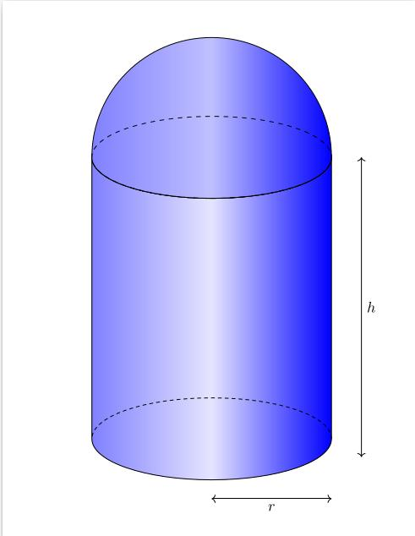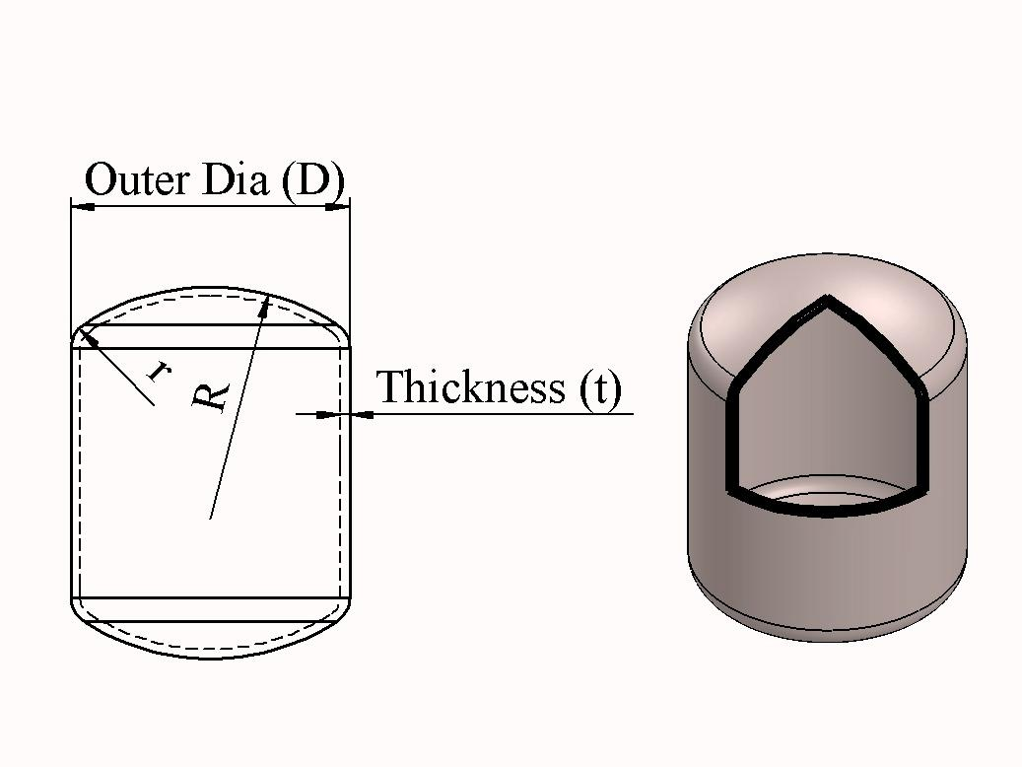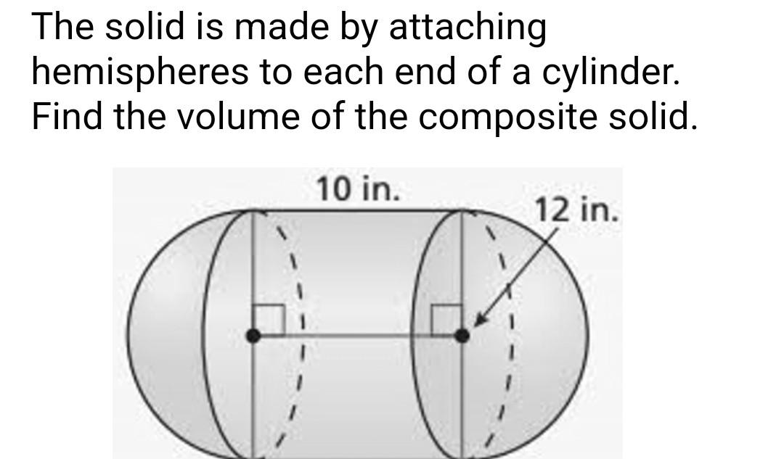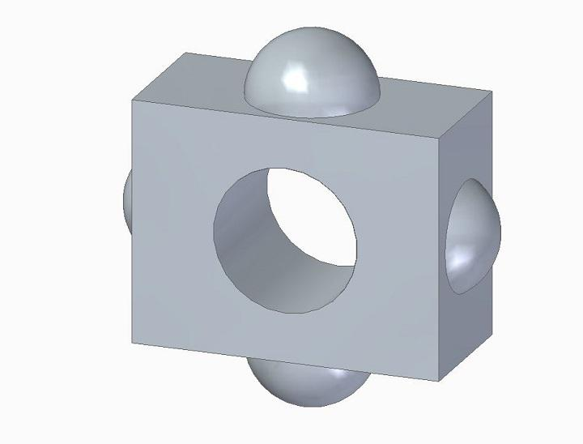
- Stacked Arrangement: Hemispherical and flat-faced components are placed above or below one another.
- End-to-End Arrangement: Components are connected consecutively along a common direction.
- Side-Attached Arrangement: Hemispherical components are attached to side faces or regions of flat-faced components.
- Coaxial Arrangement: Hemispheres and cylindrical components share a common central axis.
- Base-to-Base Arrangement: Two hemispheres are joined through their flat circular bases.
- Multi-Directional Arrangement: Hemispherical components extend in different directions from a central component.

Mathematical Properties and Formulas
# Source: AI Source: Provided by: [Data Path: Persons Table -> ID Column: 1, Name_En Column: Motasem Essam] -> From: [ChatGPT] on [7/25/2026]
The volume and surface area depend on the dimensions, shapes, and joining arrangements of the component solids.

Volume
# Source: AI Source: Provided by: [Data Path: Persons Table -> ID Column: 1, Name_En Column: Motasem Essam] -> From: [ChatGPT] on [7/25/2026]
For components joined without overlapping interiors:
$$V_{total}=\sum_{i=1}^{n}{V_{i}}$$
For a composite solid containing a rectangular prism and a hemisphere:
$$V_{total}=V_{prism}+V_{hemisphere}$$
Rectangular prism:
$$V_{p}=lwh$$
Hemisphere:
$$\boxed{V_{h}=\frac{2}{3}πr^{3}}$$
Where:
- $r$ = radius of the hemisphere.
- $l$ = length of the rectangular prism.
- $w$ = width of the rectangular prism.
- $h$ = height of the rectangular prism.
Therefore:
$$\boxed{V_{total}=lwh+\frac{2}{3}πr^{3}}$$
For two hemispheres with different radii:
$$V_{total}=\frac{2}{3}πr_{1}^{3}+\frac{2}{3}πr_{2}^{3}$$

Surface Area
# Source: AI Source: Provided by: [Data Path: Persons Table -> ID Column: 1, Name_En Column: Motasem Essam] -> From: [ChatGPT] on [7/25/2026]
The external surface area is calculated by adding all exposed surfaces and excluding hidden joining regions.
For a rectangular prism:
$${SA}_{p}=2(lw+lh+wh)$$
For a hemisphere:
Curved surface area:
$${CSA}_{h}=2πr^{2}$$
Total surface area, including the circular base:
$${SA}_{h}=3πr^{2}$$
If a hemisphere is attached to a rectangular prism through its entire circular base:
$${SA}_{total}={SA}_{p}+3πr^{2}-2πr^{2}$$
Simplifying:
$$\boxed{{SA}_{total}={SA}_{p}+πr^{2}}$$
This assumes the hemisphere's circular base is completely contained within one flat face of the prism, so the entire joining region is hidden.
For a cylinder with two hemispherical ends of the same radius:
$${SA}_{total}=2πrh+4πr^{2}$$
Where:
- $r$ = common radius.
- $h$ = length of the cylindrical middle section.
This formula includes the cylinder's curved lateral surface and both hemispheres' curved surfaces. It excludes the two hidden circular joining faces.

Worked Examples

Example 1: Rectangular Prism with a Hemisphere on Top
# Source: AI Source: Provided by: [Data Path: Persons Table -> ID Column: 1, Name_En Column: Motasem Essam] -> From: [ChatGPT] on [7/25/2026]
Given:
- Rectangular prism: $10×8×6$ cm.
- Hemisphere radius: $2$ cm.
- The hemisphere is attached to the top face, with its circular base completely inside that face.
Step 1: Calculate the rectangular prism volume.
$$V_{p}=10×8×6$$
$$V_{p}=480{ cm}^{3}$$
Step 2: Calculate the hemisphere volume.
$$V_{h}=\frac{2}{3}π(2)^{3}$$
$$V_{h}=\frac{16π}{3}{ cm}^{3}$$
Step 3: Calculate total volume.
$$V=480+\frac{16π}{3}$$
$$\boxed{V≈496.76{ cm}^{3}}$$
Step 4: Calculate the rectangular prism surface area.
$${SA}_{p}=2(10×8+10×6+8×6)$$
$${SA}_{p}=376{ cm}^{2}$$
Step 5: Calculate the hemisphere curved surface area.
$${CSA}_{h}=2π(2)^{2}$$
$${CSA}_{h}=8π{ cm}^{2}$$
Step 6: Calculate the external surface area.
The hemisphere's circular base and the corresponding circular region on the prism are hidden:
$$SA=376+8π$$
$$\boxed{SA≈401.13{ cm}^{2}}$$

Example 2: Cylinder with Two Hemispherical Ends
# Source: AI Source: Provided by: [Data Path: Persons Table -> ID Column: 1, Name_En Column: Motasem Essam] -> From: [ChatGPT] on [7/25/2026]
Given:
- Cylinder radius: $3$ cm.
- Cylinder height: $8$ cm.
- Two hemispheres, each with radius $3$ cm.
- Each hemisphere is attached to one circular end of the cylinder.
Step 1: Calculate the cylinder volume.
$$V_{c}=π(3)^{2}(8)$$
$$V_{c}=72π{ cm}^{3}$$
Step 2: Calculate the volume of two hemispheres.
Two hemispheres of equal radius form one complete sphere:
$$V_{h}=2(\frac{2}{3}π(3)^{3})$$
$$V_{h}=36π{ cm}^{3}$$
Step 3: Calculate total volume.
$$V=72π+36π$$
$$\boxed{V=108π≈339.29{ cm}^{3}}$$
Step 4: Calculate the cylinder's exposed curved surface area.
$${CSA}_{c}=2πrh$$
$${CSA}_{c}=2π(3)(8)=48π$$
Step 5: Calculate the curved surface area of two hemispheres.
$${CSA}_{h}=2(2πr^{2})$$
$${CSA}_{h}=4π(3)^{2}=36π$$
Step 6: Calculate total external surface area.
$$SA=48π+36π$$
$$\boxed{SA=84π≈263.89{ cm}^{2}}$$

Important Characteristics
# Source: AI Source: Provided by: [Data Path: Persons Table -> ID Column: 1, Name_En Column: Motasem Essam] -> From: [ChatGPT] on [7/25/2026]
- Mixed Surface Geometry: The solid contains planar surfaces and hemispherical curved surfaces.
- Multiple Components: It is constructed from two or more geometric solids.
- Hemispherical Components: These include complete hemispheres with circular flat bases.
- Flat Joining Regions: Hemispheres can connect to prisms, cylinders, cubes, and other components through circular regions.
- Variable Orientation: Hemispheres can be positioned above, below, beside, or around other solids.
- Variable Dimensions: Components may have different radii, heights, and base dimensions.
- Volume Calculation: Component volumes are added when their interiors do not overlap.
- Surface Area Calculation: Only exposed surfaces contribute to external surface area.

Comparison with Other Surface Combinations
# Source: AI Source: Provided by: [Data Path: Persons Table -> ID Column: 1, Name_En Column: Motasem Essam] -> From: [ChatGPT] on [7/25/2026]
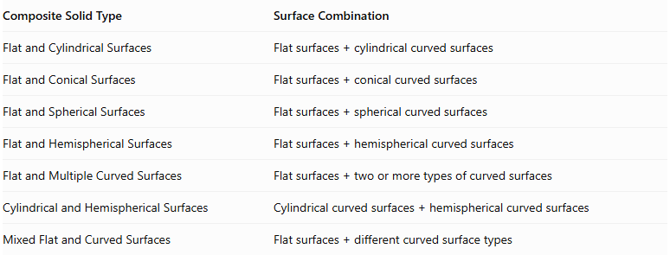
Composite Solid Type | Surface Combination
Flat and Cylindrical Surfaces | $$Flatsurfaces+cylindricalcurvedsurfaces$$
Flat and Conical Surfaces | $$Flatsurfaces+conicalcurvedsurfaces$$
Flat and Spherical Surfaces | $$Flatsurfaces+sphericalcurvedsurfaces$$
Flat and Hemispherical Surfaces | $$Flatsurfaces+hemisphericalcurvedsurfaces$$
Flat and Multiple Curved Surfaces | $$Flatsurfaces+twoormoretypesofcurvedsurfaces$$
Cylindrical and Hemispherical Surfaces | $$Cylindricalcurvedsurfaces+hemisphericalcurvedsurfaces$$
Mixed Flat and Curved Surfaces | $$Flatsurfaces+differentcurvedsurfacetypes$$

Applications
# Source: AI Source: Provided by: [Data Path: Persons Table -> ID Column: 1, Name_En Column: Motasem Essam] -> From: [ChatGPT] on [7/25/2026]
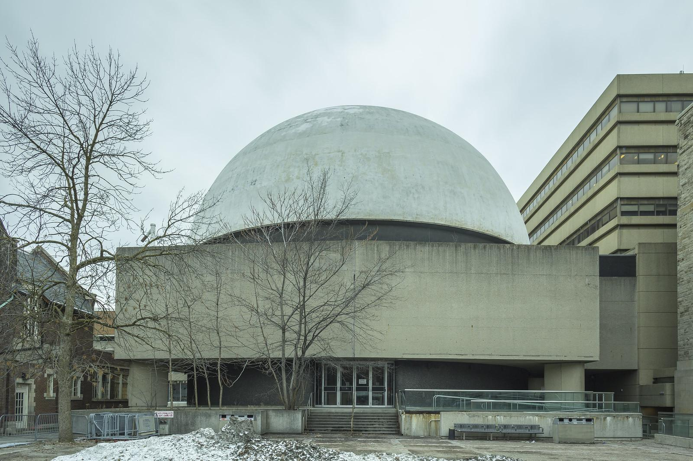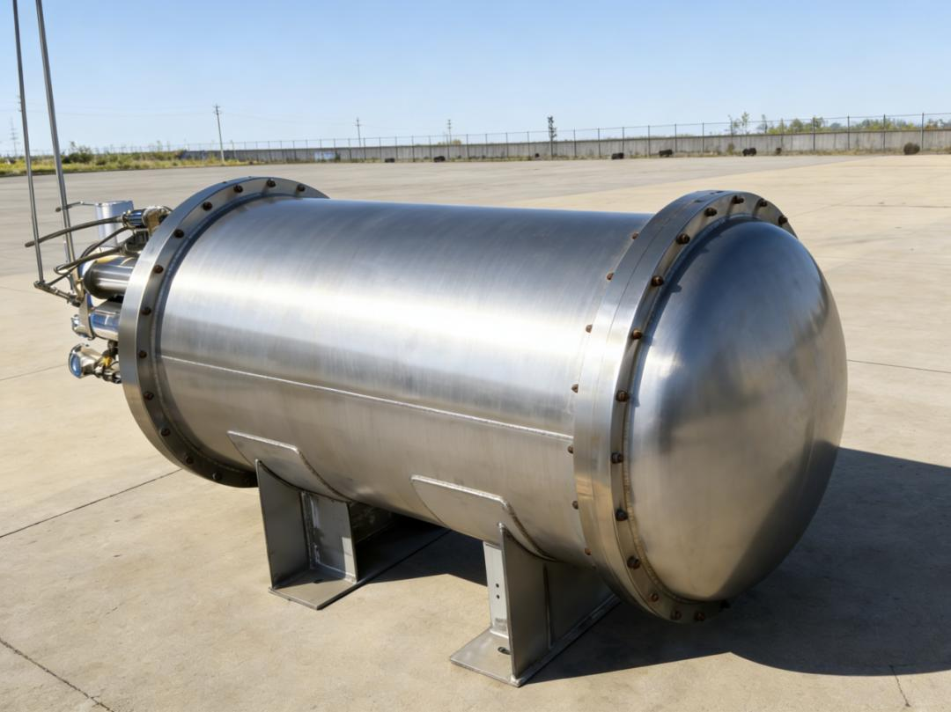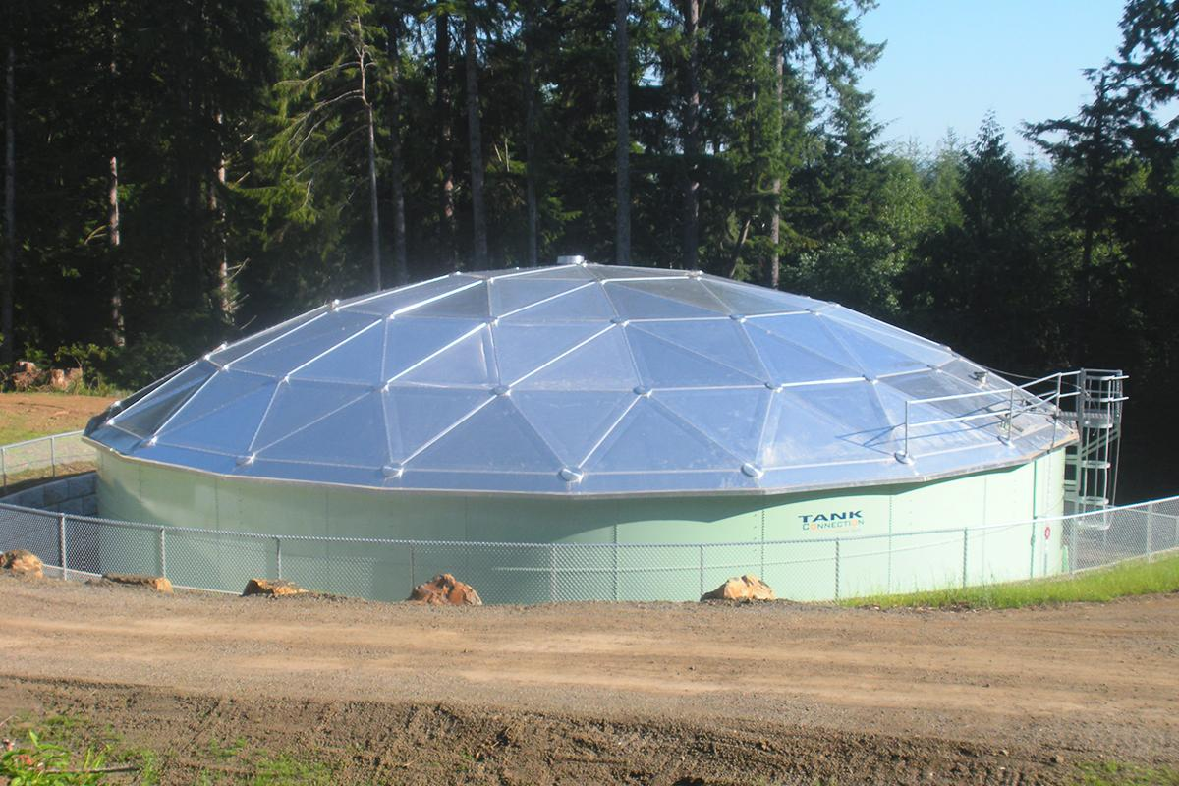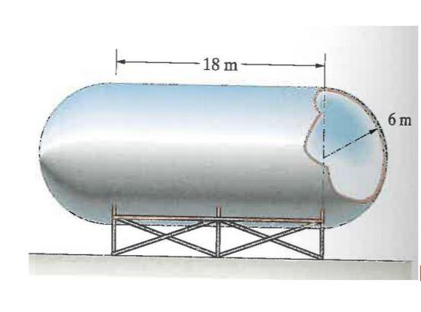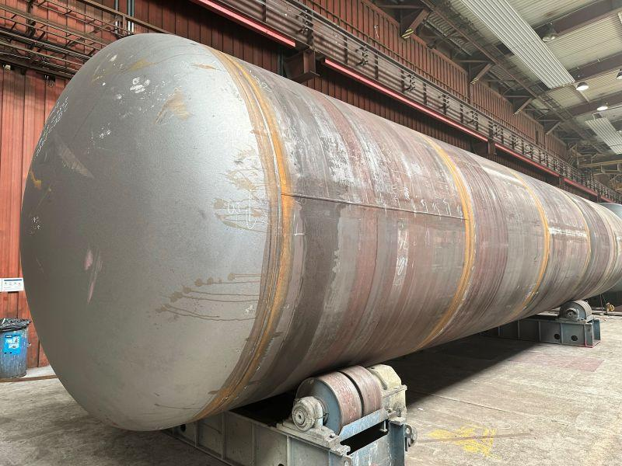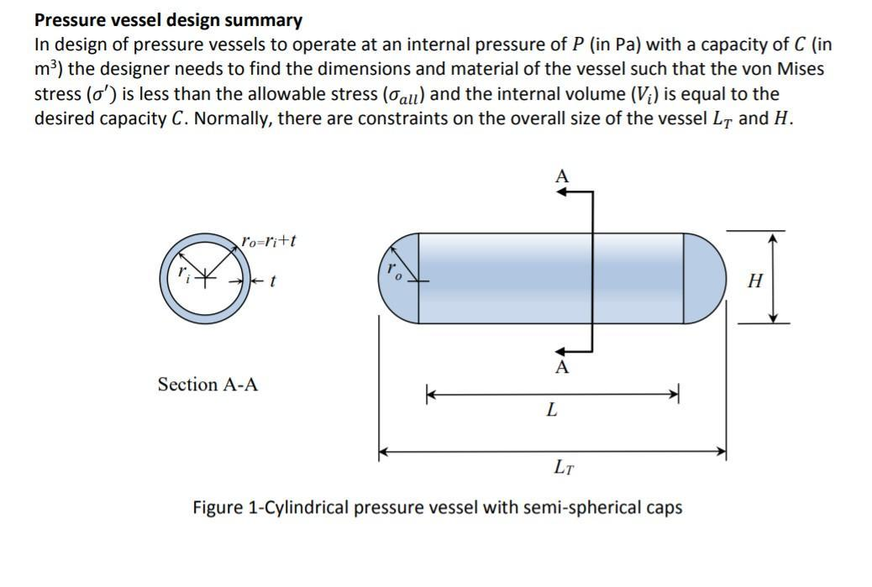
- Architecture: Hemispherical domes supported by rectangular or polygonal structures.
- Industrial Storage: Tanks and pressure vessels with hemispherical ends.
- Mechanical Engineering: Components combining hemispherical surfaces with flat supporting structures.
- Construction: Domes and hemispherical covers attached to flat-faced buildings.
- Product Design: Objects combining flat bases with hemispherical components.

Key Points
# Source: AI Source: Provided by: [Data Path: Persons Table -> ID Column: 1, Name_En Column: Motasem Essam] -> From: [ChatGPT] on [7/25/2026]
- These composite solids combine flat surfaces with hemispherical curved surfaces.
- They can include prisms, cubes, cylinders, pyramids, and hemispheres.
- Their arrangements include stacked, side-attached, coaxial, base-to-base, and end-to-end configurations.
- The volume of a hemisphere is half the volume of a sphere with the same radius.
- The curved surface area of a hemisphere is half the curved surface area of a sphere.
- Hidden circular joining regions must be excluded when calculating external surface area.
- A hemisphere has one flat circular base and one curved hemispherical surface.

Conclusion
# Source: AI Source: Provided by: [Data Path: Persons Table -> ID Column: 1, Name_En Column: Motasem Essam] -> From: [ChatGPT] on [7/25/2026]
Composite Solids with Flat and Hemispherical Surfaces are three-dimensional structures that combine planar faces with hemispherical curved surfaces. They can be constructed from different combinations of prisms, cylinders, pyramids, and hemispheres.
Their geometric analysis requires calculating the volume of each component and identifying the exposed surfaces while excluding hidden circular joining regions.

